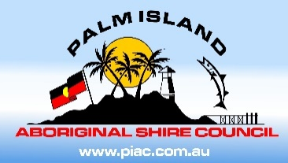**PALM ISLAND ABORIGINAL SHIRE COUNCIL**

1 MAIN STREET, PALM ISLAND QLD 4816

PH: 07 47700200

E: [Michael.Bissell@palmcouncil.qld.gov.au](mailto:Michael.Bissell@palmcouncil.qld.gov.au)

ABN: 68 799 811 816

Website: [www.palmcouncil.qld.gov.au](http://www.palmcouncil.qld.gov.au)

**PALM ISLAND ABORIGINAL SHIRE COUNCIL**

**SPECIAL MEETING NOTICE**

In accordance with Section 254C (2) (b) of the *Local Government Regulation 2009*, Notice is hereby given today **Friday 14th March 2025,** that the Palm Island Aboriginal Shire Council Special Meeting will be held:

**FRIDAY 21TH MARCH 2025, COMMENCING AT 10.00AM**

**PIASC BOARDROOM**

Michael Bissell

Chief Executive Officer

PALM ISLAND ABORIGINAL SHIRE COUNCIL